**EVENTS INSIDE VIT**

Submitted By,

Sivanesan A (12MSE0239)

Balaji S (12MSE0105)

**OBJECTIVE**

To make the event announcement more effective for easy maintenance of all events than normal conventional method of announcement. To integrate the events in a single environment that are conducted in the university .This benefits the students while reducing the need to look at different website for different events.

**INTRODUCTION**

EventsInsideVIT is an information and event sharing web application. It aims to reach the information to the user of the web. Since it is a web application from basic framework to utmost designs are written in HTML, CSS, JQuery, JSON, and AJAX for client side processes. The server side processes are written PHP, MYSQL. This web application is not centered for desktop users. It also encompasses the PDA users also so that maximum utility can be achieved. The server here used is the local machine which will be later transferred to a dedicated server for more storage, performance and security reasons.

The existing system used for broadcasting the information and events are mainly through posting the bills on the walls, Facebook links of the clubs, announcements in class rooms, advertising through banners, registration desks etc. Theses conventional methods of information sharing which is way off the contemporary world. Because informer has not knowledge of interest of the listener. For instance, announcer who is intended to convey the information for the mechanical branch may not have the knowledge of student in the class and announcing the information to computer science, civil, electronic or other branch students. This results in waste of effort and time etc. To overcome the difficulties a system parallel to modern world is necessary for the welfare of the people

The emerging system should not also be too conservative. For that an open platform usable, affordable for everyone is necessary. A pragmatic approach can be web based application, as the web applications can be viewed by everyone who has any kind of PDA, PCs etc. This system will help the user to be focus on his intended user, convey the information to user within minutes, get feedback from users, and inform the changes to users. The proposed system is most common approach for such problems. The information sender can actually select the intended users and propagate the message to them. This does not require any adverts as to promote the information as the information sender as reached the intended users. This may help in rapid communication between the information sender and the receiver. The process to confirm the event happening is made online so the event owner can send a request to faculty coordinator for approval. Both of the user i.e. the event owner and the user are benefitted through circumventing the manual works.

The system has been implemented as a web application so that large users can served without using additional resources or application. The server-side scripting is written in PHP and MYSQL server for data storage.

**DRAWBACK OF EXISTING SYSTEM**

The existing system for events sharing is announcing which is conventional method. This method is outdated and unparalleled mode of communication. It lacks the communication of audience. It is lot slower, difficult to update. The most audience are unable to perceive information from the announcement as its incomplete data.

Some common methods of propaganda are through

* + Poster
  + Announcements
  + Facebook pages
  + Banners
  + Sticking posters along the pedestrian pathway
  + Websites for every club events.

The conventional method is not updated with latest technology which the students have. This creates an unparalleled communication which results in improper communication. It also does not integrate events which causes important events to be missed.

**OBJECTIVES OF PROPOSED SYSTEM**

To make the event announcement more effective for easy maintenance of all events than normal conventional method of announcement. To integrate the events in a single environment that are conducted in the university .This benefits the students while reducing the need to look at different website for different events.

**SYSTEM ARCHITECTURE**

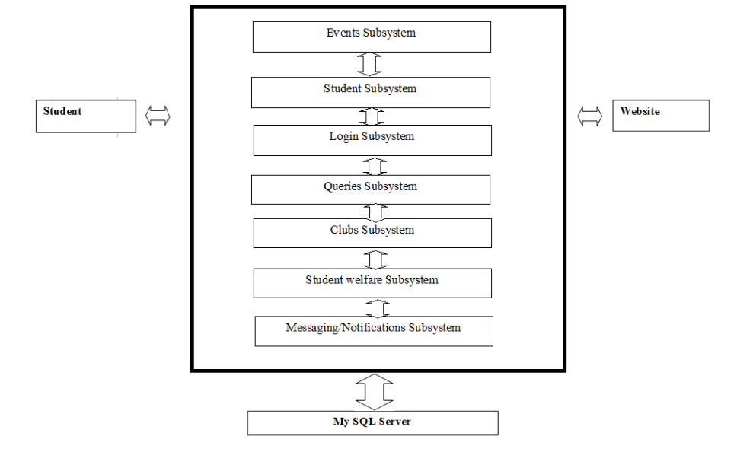

**DATAFLOW**

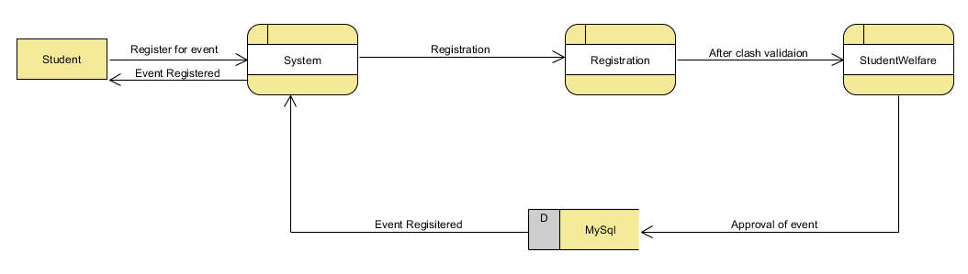

**System specification**

HARDWARE SPECIFICATION

* Processor: core i3 or higher
* RAM: 2GB
* Hard disk: 200 GB

SOFTWARE SPECIFICATION

* OS: windows 7 or windows 8 or higher
* LANGUAGE: C#
* IDE: Visual studio 2013
* DATABASE: SQL Server 2012

**MODULE DESCRIPTION**

1. Login
2. Student
3. Event Owner
4. Club
5. Bulletin board
6. Student welfare
7. Filtering and Subscription
8. Messaging and Notification
9. Querying

**Screenshots:**

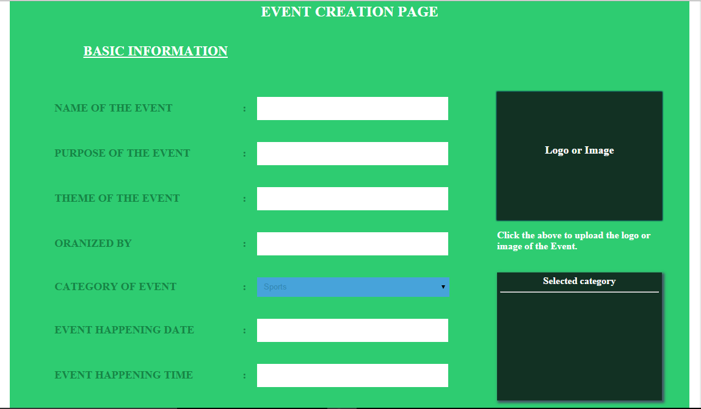

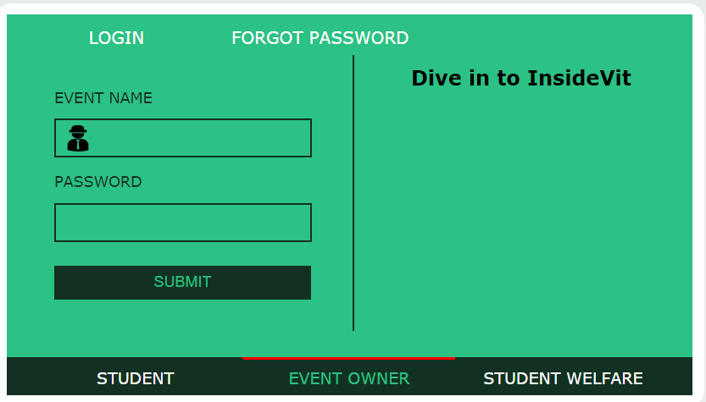

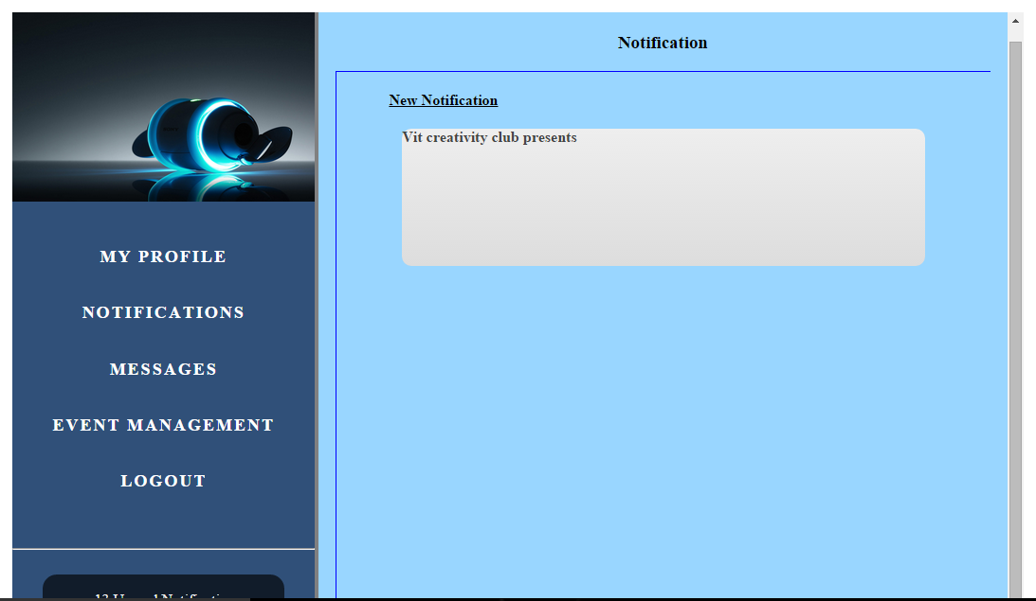

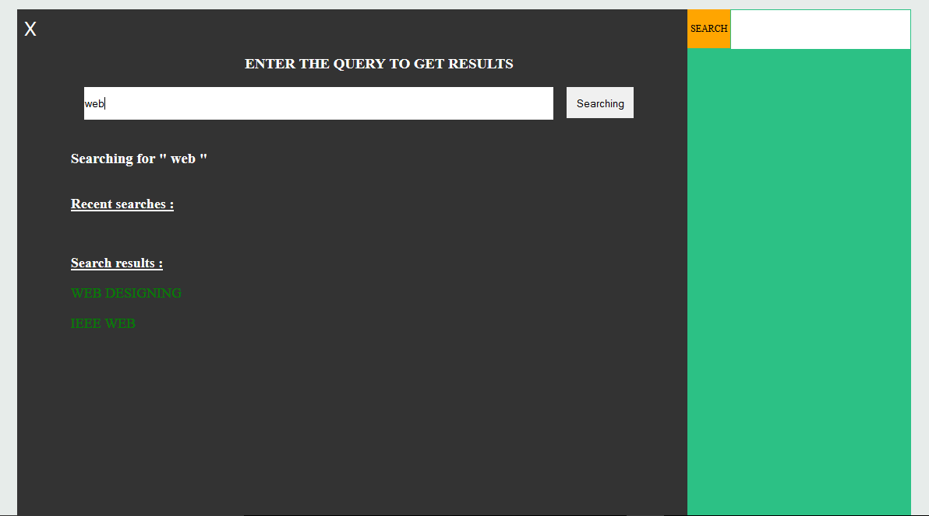

**SCM Concepts**

* Process management - Ensuring adherence to the organization's development process
* Build management - Managing the process and tools used for builds
* Configuration status accounting - Recording and reporting all the necessary information on the status of the development process.
* Version Control - allows you to control and monitor changes to files
* Teamwork - Facilitate team interactions related to the process.
* Configuration status accounting - Recording and reporting all the necessary information on the status of the development process.
* Configuration auditing - Ensuring that configurations contain all their intended parts and are sound with respect to their specifying documents, including requirements, architectural specifications and user manuals.

**Tools for configuration management**

* Chef
* Puppet
* CFEngine
* Juju
* IBM ClearCase
* SaltStack Enterprise DevOps
* Capistrano